Infosys Springboard Virtual Internship 7.0 Frontend Completion Report
Team Details

Batch Number: 1
Start Date: June 27,2026
Names: Akash keote,krishna shalwadi,goukulan,areeb,Hema nandini,shirsa roy
Internship Duration: 8 weeks

1. Project Title
Government Subsidy & Grant Disbursement Tracking System

2. Project Objective
The primary objective of the Government Subsidy & Grant Disbursement Tracking System is to build a secure, transparent, scalable, and user-centric digital platform that centralizes the management of government subsidy and grant schemes for all key stakeholders, including citizens, Village Level Entrepreneurs (VLEs), verification officers, sanction officers, finance officers, and administrators.
The system is designed to simplify the process of discovering government schemes and applying for eligible subsidies and grants through a centralized online platform. Citizens can view available schemes, understand their eligibility requirements, submit applications, upload the required documents, and track the progress of their applications. This reduces dependency on manual paperwork, minimizes delays, and provides applicants with better visibility into the status of their requests.
A core objective of the system is to establish a structured and efficient application verification, sanction, and disbursement lifecycle. Applications submitted by citizens can pass through different levels of verification and approval before reaching the finance stage. Verification officers can review submitted applications and documents, sanction officers can process eligible applications, and finance officers can manage disbursement-related activities. This helps establish a systematic workflow and improves accountability throughout the subsidy and grant distribution process.
The system further emphasizes transparency, security, and role-based access control. Different stakeholders are provided with role-specific dashboards and functionalities according to their responsibilities. Authentication and authorization mechanisms help ensure that users can access only the information and operations permitted for their roles. Application records, verification activities, sanction decisions, and disbursement information can be managed through a centralized system, improving traceability and reducing the possibility of unauthorized access or manual errors.
The platform also aims to improve the overall efficiency of government subsidy administration by providing centralized scheme information, application tracking, notifications, dashboards, reports, and finance-related monitoring. By digitizing the complete workflow, the system helps reduce administrative overhead, improve communication between stakeholders, and provide citizens with a more accessible and transparent subsidy application experience.
From a technical standpoint, the objective includes implementing a modern full-stack architecture using:
• React + Vite + TypeScript for developing a responsive, modular, and role-based frontend application.
• React Router for implementing navigation and protected routes for different user roles such as citizens, VLEs, verification officers, sanction officers, finance officers, and administrators.
• Axios + TanStack React Query for efficient communication between the frontend and backend APIs, including API requests, loading states, error handling, and data management.
• Tailwind CSS + reusable React components for creating a consistent, responsive, and maintainable user interface.
• Java + Spring Boot for developing secure, modular, and scalable backend REST APIs and implementing the core business logic of the subsidy and grant management system.
• Spring Security + JWT for implementing secure authentication and role-based authorization across different modules and user roles.
• PostgreSQL + Spring Data JPA/Hibernate for persistent storage and management of users, schemes, applications, verification information, sanction details, and other system data.
• Maven, Git, and GitHub for project building, dependency management, version control, source-code collaboration, and team-based development.
Overall, the project aims to provide a centralized digital ecosystem for government subsidy and grant management, enabling efficient application processing, transparent verification and sanction workflows, secure data management, and improved accessibility for citizens and government stakeholders.

3. Project Description in Detail
The Government Subsidy & Grant Disbursement Tracking System is a comprehensive web-based platform designed to digitize and streamline the complete lifecycle of government subsidy and grant applications. The system provides a centralized environment where citizens can discover government schemes, submit applications, upload required documents, and track application progress, while government officials can perform verification, sanction, and finance-related activities.
The application follows a modular full-stack architecture consisting of a Presentation Layer (Frontend), Application Layer (Backend), and Data Layer (Database). The system also incorporates role-based access control to provide different functionalities to citizens, Village Level Entrepreneurs (VLEs), verification officers, sanction officers, finance officers, and administrators.

System Architecture

- Presentation Layer (Frontend): Developed using React, Vite, and TypeScript, this layer provides a responsive and interactive user interface for citizens, VLEs, government officers, finance users, and administrators. The frontend handles authentication, scheme browsing, application submission, document upload, application tracking, dashboards, notifications, and other role-specific operations. React Router is used for navigation and protected routes, while reusable components and Tailwind CSS are used to maintain a consistent and responsive interface.
- Application Layer (Backend): Built using Java and Spring Boot, this layer manages the core business logic and RESTful APIs of the system. The backend follows a feature-based Modular Monolith architecture, with major modules such as authentication, scheme management, and application management. Spring Security and JWT are used for authentication and role-based authorization, while Spring Data JPA is used for database interaction and persistence.
- Data Layer (Database): The system uses PostgreSQL for persistent data management. Spring Data JPA/Hibernate provides object-relational mapping between Java entities and database tables. The database stores information related to users, government schemes, applications, application status, verification details, and other subsidy and grant processing information. Database migration support is provided through Flyway-related dependencies.

Functional Modules

- User Management Module: Handles user registration, login, authentication, and role-based access to the system. Different user roles are provided with appropriate dashboards and permissions. JWT-based authentication and Spring Security help protect restricted resources and prevent unauthorized access.
- Government Scheme Management Module:Provides a centralized collection of government subsidy and grant schemes. Users can browse available schemes and view relevant information required for applying. The backend provides APIs for retrieving scheme information, while the frontend displays the schemes in an accessible and user-friendly format.
- Subsidy & Grant Application Module: Allows eligible citizens or authorized users to initiate and submit applications for government schemes. The module manages application information and connects the applicant with the subsequent verification and approval workflow.
- Document Upload Module: Supports the submission of documents required for subsidy and grant applications. Uploaded documents form part of the application process and allow verification officers to review the supporting information before an application progresses to the next stage.
- Application Verification Module:Provides functionality for verification officers to review submitted applications and supporting documents. The verification stage helps determine whether the submitted information satisfies the requirements before the application proceeds toward sanction.
- Sanction & Approval Module: Provides a dedicated workflow for sanction-level officers to review verified applications and make appropriate approval or rejection decisions. This creates a structured transition between verification and financial processing.
- Finance & Disbursement Module: Supports finance-related processing of approved subsidy and grant applications. Finance users can manage disbursement-related activities and maintain information associated with the financial processing stage.
- Application Tracking Module: Allows applicants to monitor the progress of their applications throughout the processing lifecycle. Status information provides visibility into different stages such as submission, verification, sanction, and finance/disbursement processing.
- Role-Based Dashboard Module:The system provides separate dashboards for different stakeholders, including Citizen, VLE, L1 Verification Officer, L2 Sanction Officer, L3 Finance Officer, and Administrator. Each dashboard is designed according to the responsibilities and information requirements of the corresponding role.
- Notification & Profile Module: Provides users with access to notifications and profile-related information. This helps users remain informed about application-related activities and manage their account information through the portal.
- Reporting & Monitoring Module: Provides reporting and monitoring capabilities for administrative and sanction-related activities. These features help authorized users review application information and monitor the overall subsidy and grant processing workflow.

Technology Stack
- Backend: Java, Spring Boot, Spring Security, JWT, Maven, Spring Data JPA/Hibernate
- Frontend: React, Vite, TypeScript, React Router, Axios, TanStack React Query, Tailwind CSS, Motion, Lucide React
- Database: PostgreSQL, JPA/Hibernate
- API & Integration: RESTful APIs, Axios, JSON-based request and response communication
- Development & Version Control Tools: Git, GitHub, Visual Studio Code / IntelliJ IDEA, Maven
- Deployment & Infrastructure Support: Docker, Docker Compose, GitHub Actions

Real-World Impact
The Government Subsidy & Grant Disbursement Tracking System aims to reduce the dependency on manual and paper-based subsidy processing by providing a centralized digital platform for scheme discovery, application submission, document verification, sanction, finance processing, and application tracking.
The system improves transparency and accountability by providing a structured workflow in which applications move through defined verification, sanction, and finance stages. Role-based dashboards ensure that different stakeholders can access the information and operations relevant to their responsibilities.
For citizens, the platform provides easier access to government schemes and greater visibility into application progress. For government officials, it provides centralized application information and role-specific tools that can reduce administrative effort and improve workflow management.
From a technical perspective, the project demonstrates the practical application of React-based frontend development, Spring Boot backend development, REST API integration, JWT authentication, role-based authorization, PostgreSQL database management, Git/GitHub collaboration, and Agile software development practices.
Future enhancements could include advanced analytics dashboards, automated eligibility checking, integration with additional government databases and services, digital signature support, automated document verification, SMS/email notifications, enhanced reporting, and mobile application support. These enhancements could further improve the accessibility, transparency, and efficiency of government subsidy and grant administration.

4. Timeline Overview

Week | Activities Planned | Activities Completed
Week 1 | Requirement Analysis & Project Planning – Understand the government subsidy and grant workflow, identify stakeholders, define functional requirements, and select the technology stack. | Analyzed the problem domain and identified the major stakeholders including Citizens, VLEs, L1 Verification Officers, L2 Sanction Officers, L3 Finance Officers, and Administrators. Finalized the project requirements, technology stack, system architecture, and development responsibilities.
Week 2 | Backend & Database Setup – Initialize Spring Boot project, configure Maven, design database entities, and establish authentication and authorization. | Maven configuration. Designed the initial PostgreSQL database structure and implemented the authentication framework using Spring Security and JWT. Defined role-based access for different categories of users.
Week 3 | Frontend Foundation & Scheme Management – Develop React/Vite project structure, navigation, authentication screens, reusable components, and government scheme listing. | Developed the React, Vite, and TypeScript frontend structure. Implemented navigation using React Router, reusable UI components, authentication-related pages, role-based routes, and the government scheme listing and viewing functionality.
Week 4 | Application & Document Management – Implement subsidy/grant application forms, document upload functionality, and citizen dashboard. | Developed the subsidy and grant application workflow. Implemented application forms, document-upload functionality, citizen dashboard features, application services, and API communication between frontend and backend.
Week 5 | Verification Workflow – Develop L1 Verification dashboard and application/document review functionality. | Implemented the L1 Verification workflow. Verification officers can review submitted application information and supporting documents and perform verification-related actions. Application status handling was integrated into the workflow.
Week 6 | Sanction, Finance & Tracking – Develop L2 Sanction, L3 Finance, application tracking, notifications, and additional role-specific features. | Implemented L2 sanction functionality and L3 finance/disbursement-related operations. Developed application tracking and expanded role-specific dashboards for VLEs, officers, finance users, and administrators.
Week 7 | Integration, Testing & UI Enhancement – Connect frontend services to backend APIs, test workflows, fix bugs, improve security, and refine the user interface. | Integrated the React frontend with live backend APIs using Axios and TanStack React Query. Corrected API integration and pagination-related issues, improved loading and error states, refined the UI, and validated role-based access and application workflows.
Week 8 | Final Testing, Documentation & Deployment Preparation – Perform end-to-end validation, review the complete application, prepare documentation, and organize the final demonstration. | Completed final workflow validation and debugging. Reviewed frontend-backend integration, finalized the codebase and documentation, documented the development process, and prepared the project for final presentation and internship submission.

5a. Key Milestones

Milestone | Description | Date Achieved
Project Kickoff | Project planning, problem definition, requirement analysis, identification of stakeholders and user roles, technology selection, system architecture planning, and allocation of frontend, backend, and Agile responsibilities. | Week 1

Prototype / First  Draft | Initial working prototype with the React frontend structure, navigation, authentication, role-based routing, government scheme listing, and initial backend setup with database and authentication framework. | Week 3
Mid-Term Review | Completion of the major citizen workflow including government scheme browsing, subsidy/grant application, document upload, citizen dashboard, and initial frontend–backend API integration. | Week 5
Final Submission | Completion and integration of the major modules including L1 verification, L2 sanction, L3 finance and disbursement, application tracking, role-based dashboards, API integration, testing, debugging, and project documentation. | Week 8
Presentation | Final project demonstration showcasing the complete subsidy and grant processing workflow across Citizen, VLE, L1 Verification, L2 Sanction, L3 Finance, and Admin roles, followed by project evaluation and final presentation. | Week 8

5b. Project Execution Details
The execution of the Government Subsidy & Grant Disbursement Tracking System followed a well-planned, iterative, and milestone-based development strategy over the internship period, with continuous development, frontend and backend integration, testing, debugging, and refinement. The project was developed collaboratively by dividing responsibilities across Frontend Development, Backend Development, Database Management, API Integration, Testing, and Agile Coordination.

1. Execution Strategy and Workflow
The project followed an Agile and iterative development approach, where the overall system was divided into manageable modules and developed progressively. The team worked on frontend, backend, database, integration, and testing activities in parallel wherever possible.
The development process began with requirement analysis and technology selection, followed by system architecture and database planning. Frontend and backend modules were then developed incrementally and integrated through RESTful APIs. Regular testing and debugging were performed throughout the development process to identify integration issues and improve the overall reliability of the application.
The development workflow consisted of:
• Requirement analysis and project planning
• System architecture and database design
• Frontend interface and component development
• Backend API and business-logic development
• Authentication and role-based authorization
• Frontend–backend API integration
• Module-level and integration testing
• Bug fixing and UI refinement
• Final workflow validation and documentation
The team used Git and GitHub for source-code management and collaboration. The project was continuously refined through incremental changes, feature additions, integration updates, and bug fixes.

2. Backend Development (Spring Boot)
- Implemented the backend using Java and Spring Boot to provide RESTful APIs and manage the core business logic of the subsidy and grant management system.
• Followed a feature-based Modular Monolith architecture, organizing the backend around major business capabilities such as authentication, scheme management, and application management.
• Developed the authentication and user-management module to manage users, roles, login, and access to protected resources.
• Implemented Government Scheme Management functionality for storing and retrieving information about subsidy and grant schemes.
• Developed the Application Management module to handle subsidy and grant application submission, retrieval, status management, and application-related operations.
• Implemented backend support for the application verification and approval workflow, allowing applications to progress through different processing stages.
• Implemented role-aware functionality for Citizen, VLE, L1 Verification Officer, L2 Sanction Officer, L3 Finance Officer, and Administrator users.
• Integrated Spring Security and JWT to provide authentication and role-based authorization for protected backend resources.
• Used Spring Data JPA/Hibernate for database interaction and persistence of application and scheme-related information.
• Used PostgreSQL as the primary relational database for storing system information.
• Included validation and exception-handling mechanisms to improve the reliability of API requests and provide meaningful responses for invalid or failed operations.
• Used Maven for dependency management, project compilation, and backend build execution.
• Included database migration support through Flyway-related dependencies to maintain consistency in database changes.

3. Frontend Development (React)
• Developed a responsive and modular frontend using React, Vite, and TypeScript.
• Implemented separate role-aware interfaces for Citizens, VLEs, L1 Verification Officers, L2 Sanction Officers, L3 Finance Officers, and Administrators.
• Used React Router to implement navigation between different pages and protected routes for role-specific functionality.
• Designed reusable components to improve maintainability, consistency, and reusability across the application.
• Developed the Government Scheme Listing interface through which users can browse and view available subsidy and grant schemes.
• Developed the Citizen Dashboard to provide users with access to application-related information and activities.
• Implemented the Subsidy/Grant Application workflow, including application forms and application-related interactions.
• Implemented Document Upload functionality required as part of the subsidy and grant application process.
• Developed Application Tracking functionality so applicants can monitor the progress and status of their applications.
• Developed separate dashboards and interfaces for L1 Verification, L2 Sanction, L3 Finance, VLE, and Admin operations.
• Used Axios for communication between the React frontend and backend REST APIs.
• Integrated TanStack React Query for handling asynchronous API requests, data retrieval, loading states, and API-related state management.
• Used Tailwind CSS for responsive and consistent user-interface styling.
• Used Motion for interface animations and improved user interaction.
• Used Lucide React for consistent iconography throughout the frontend.
• Improved frontend reliability by implementing loading indicators, inline error messages, validation states, and API fallback handling where required.

4. Security Implementation
- Authentication: Implemented secure user authentication using Spring Security and JWT-based authentication to protect application resources.
• Authorization: Implemented Role-Based Access Control (RBAC) so that different users can access functionality according to their assigned roles.
• Role-Based Frontend Protection: Implemented protected routes in the React frontend torestrict access to dashboards and features intended for specific user roles.
• Backend Authorization: Backend security mechanisms ensure that protected APIs are accessible only to authorized users.
• Input Validation: Implemented validation of incoming application and user data to reduce invalid requests and improve data quality.
• Database Security: Used JPA-based parameterized database interaction to reduce the risk of common database query vulnerabilities.
• Document Handling: Application documents are handled as part of the controlled application workflow, allowing authorized verification users to review supporting documents.
• Access Control: Different levels of users are provided with access only to the operations relevant to their responsibilities, supporting separation of duties between applicants, verification officers, sanction officers, finance officers, and administrators.
.

5. Testing and Quality Assurance
• Conducted module-level testing of frontend and backend components during development.
• Performed API testing to verify communication between frontend services and backend REST endpoints.
• Tested authentication and role-based access functionality for different categories of users.
• Validated the government scheme retrieval and display workflow.
• Tested the subsidy and grant application submission workflow.
• Tested document upload and application-related operations.
• Validated application status and tracking functionality.
• Tested the L1 verification workflow and subsequent application processing stages.
• Tested L2 sanction and L3 finance-related workflows.
• Performed frontend–backend integration testing to identify API communication anddata-mapping issues.
• Tested loading, error, and fallback states when API requests were unsuccessful.
• Identified and corrected API integration issues during progressive development.
• Corrected frontend API handling and pagination-related issues to ensure that the required scheme information could be retrieved correctly.
• Performed role-based navigation testing to ensure that users were directed to the appropriate dashboards.
• Conducted final end-to-end validation of the complete application workflow from scheme discovery and application submission through verification, sanction, finance processing, and application tracking.
• Reviewed the final system for functional correctness, usability, integration reliability, and readiness for project demonstration and documentation.

6. Snapshots / Screenshots
The following screenshots show the Government Subsidy & Grant Disbursement Tracking System running on the frontend and connected to the Spring Boot backend through RESTful APIs. Each screenshot demonstrates a specific implemented feature or workflow of the system, including scheme browsing, user dashboards, subsidy and grant application processing, document submission, application tracking, verification, sanction, and finance-related activities across the different user roles.

1: Landing Page

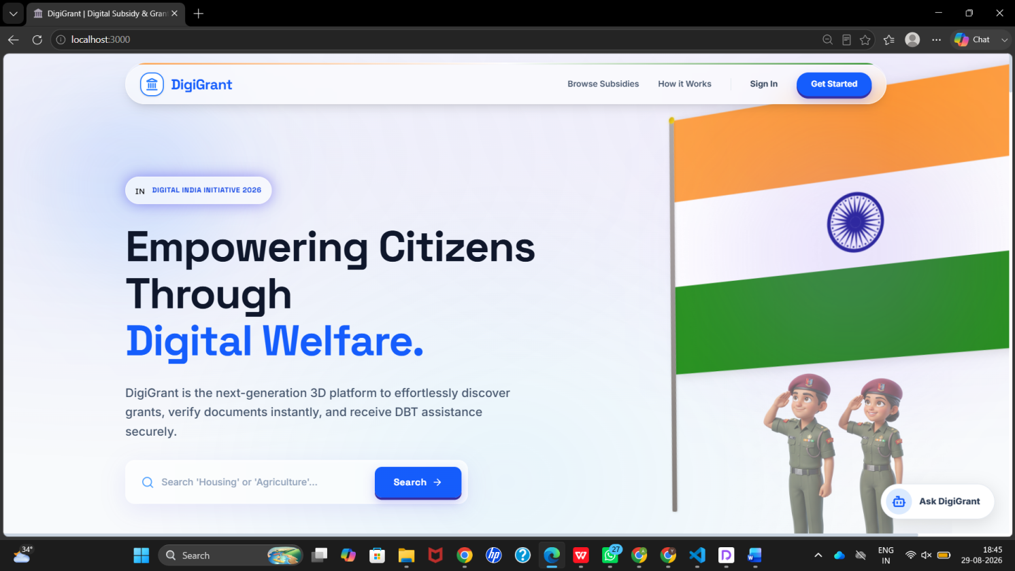

2. SignUp

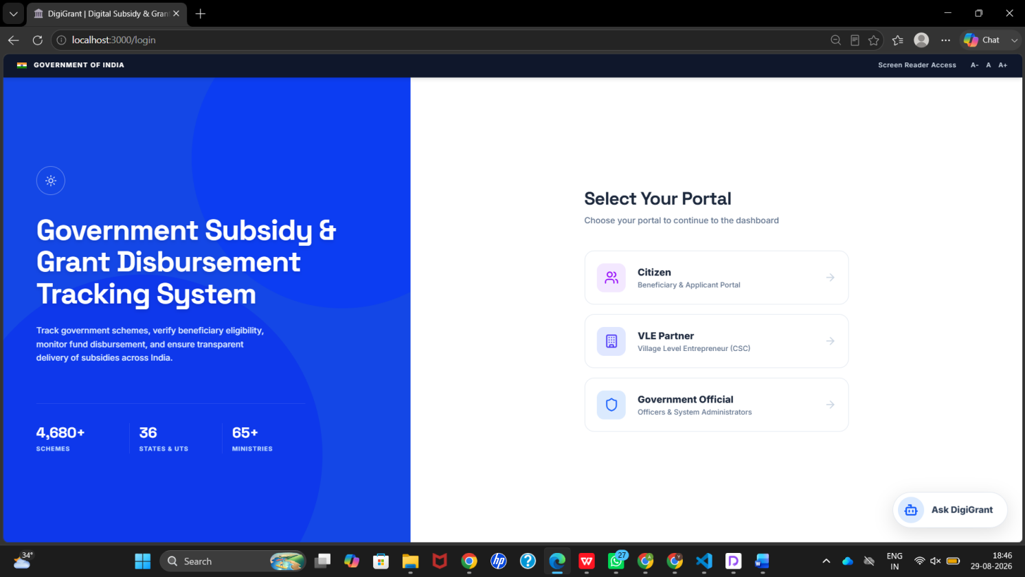
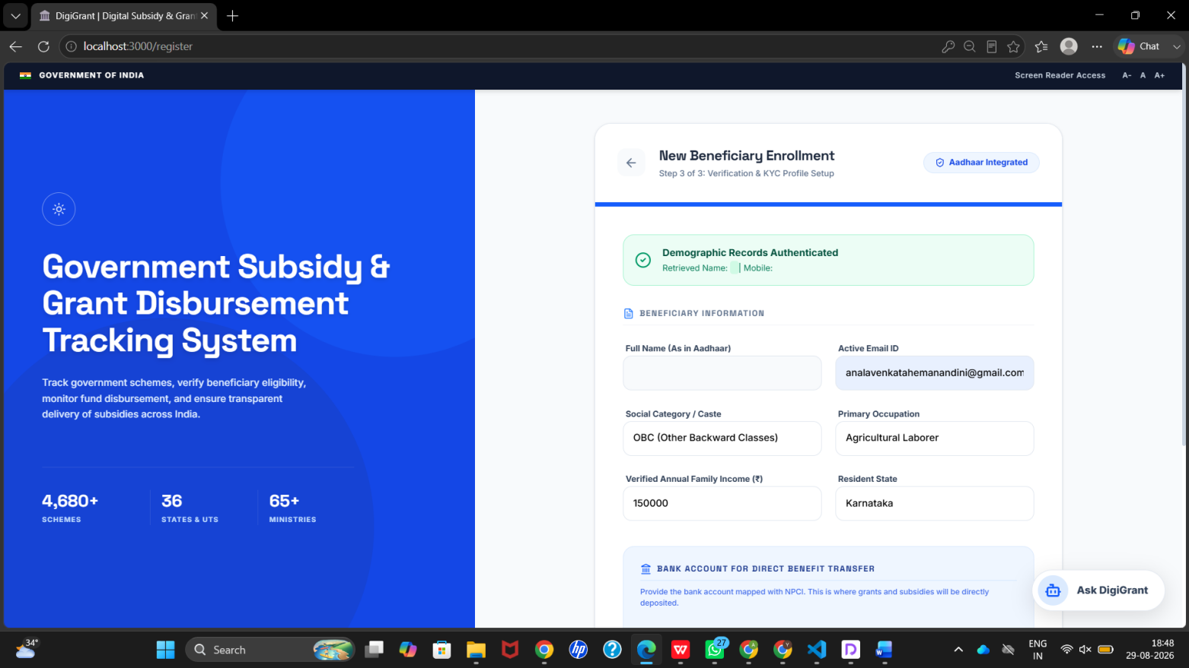

3: Login

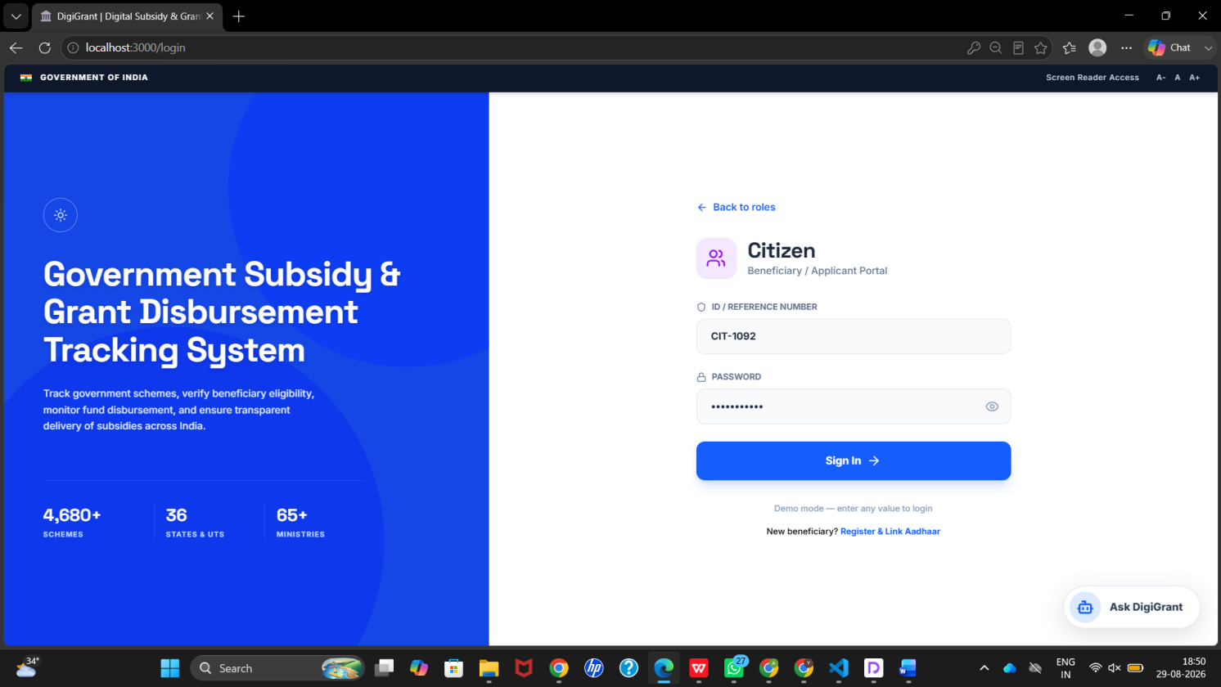

4: citizenDashboard

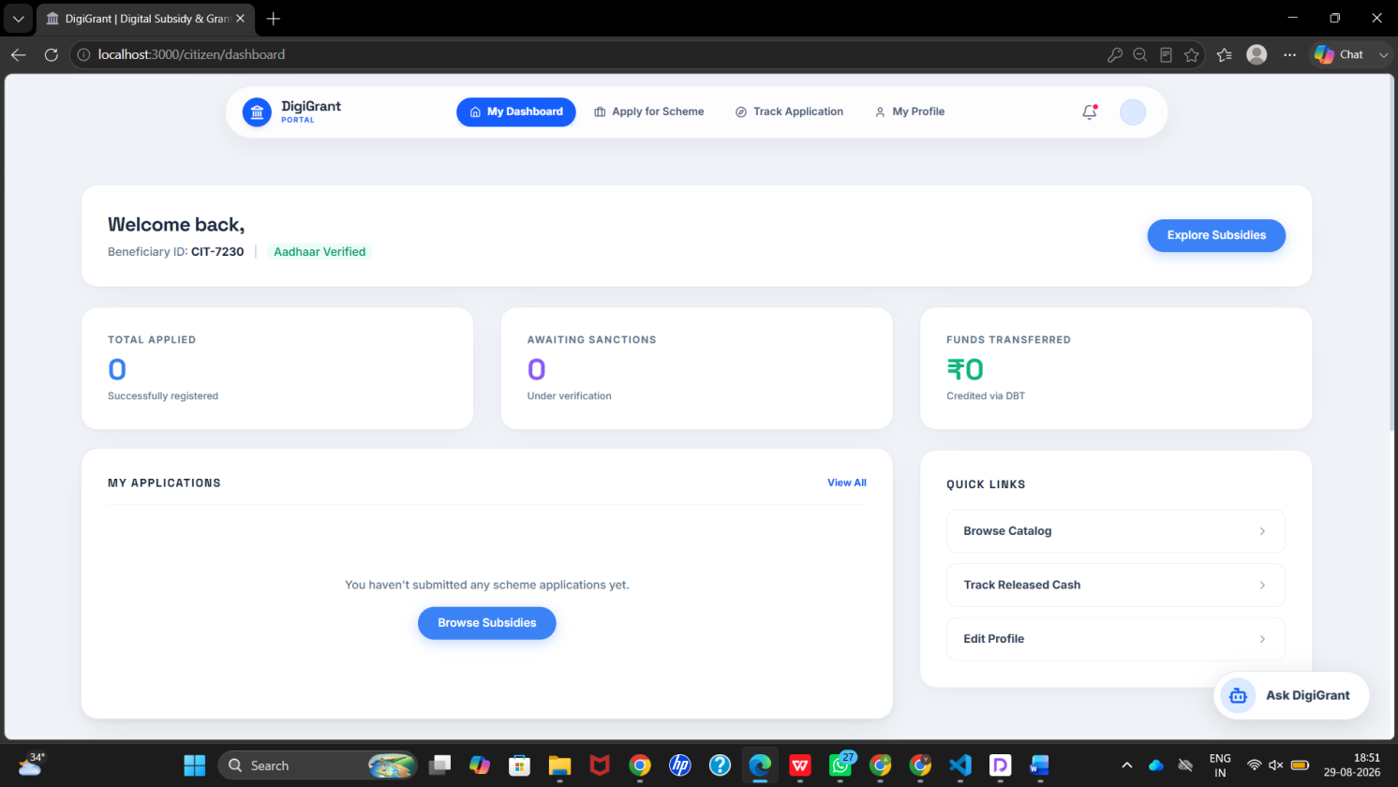
5: Applying schemes

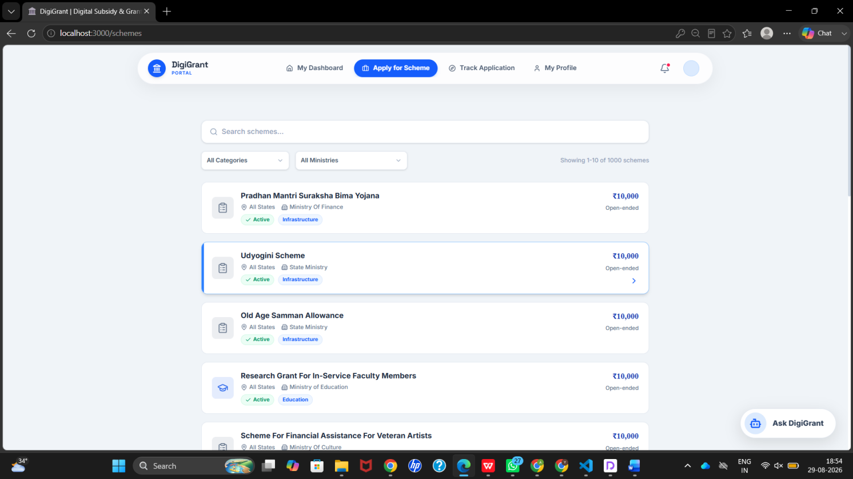

6: scheme Application
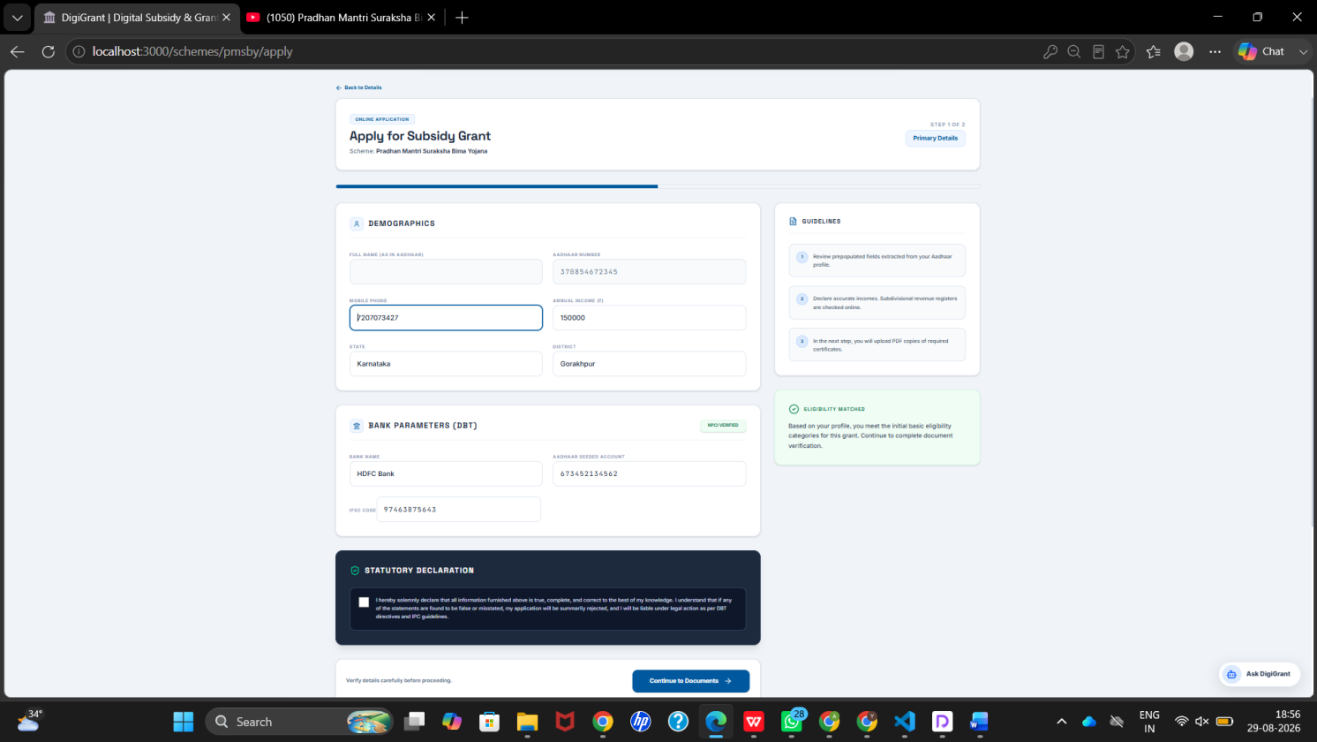
7: Track Application

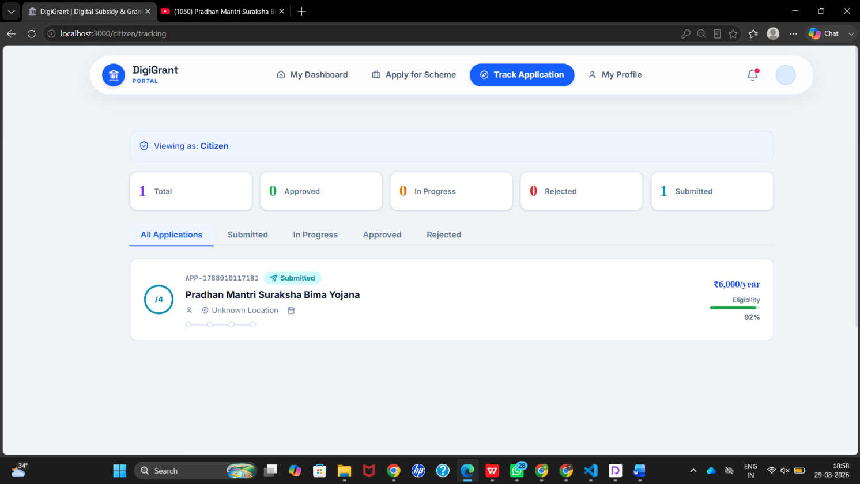

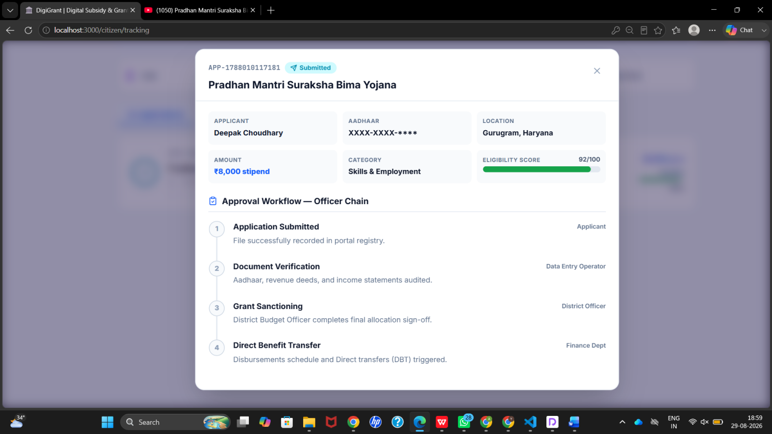

8:Village level enterprenuer

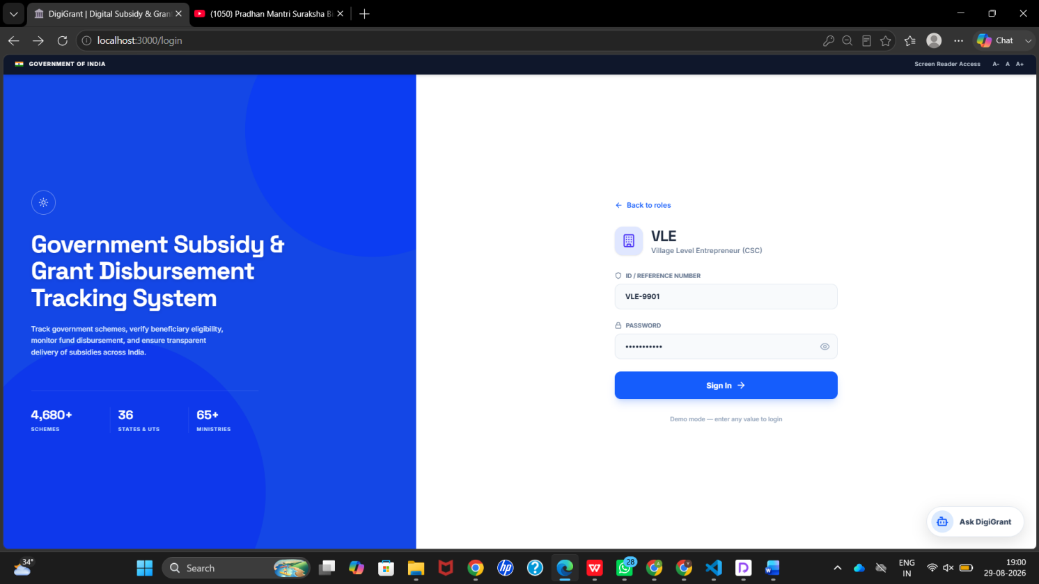

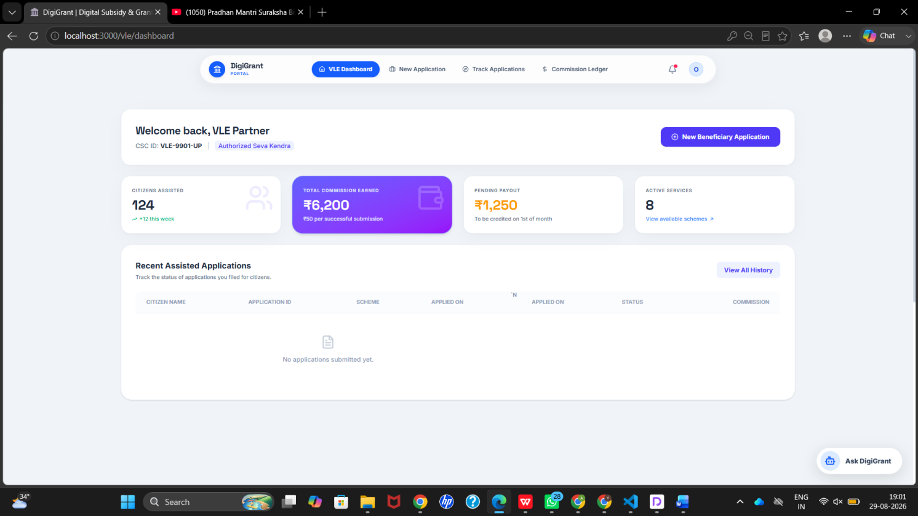

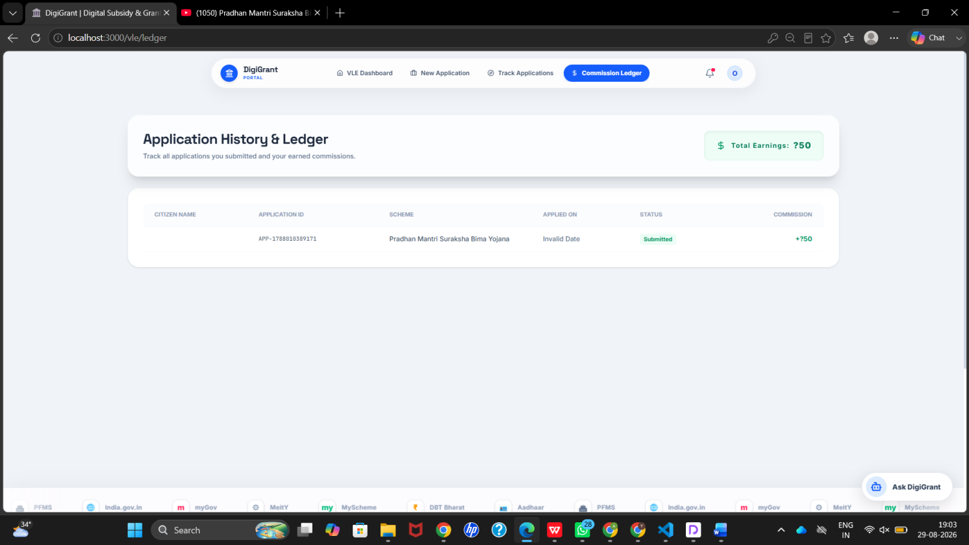
9:Government Officials

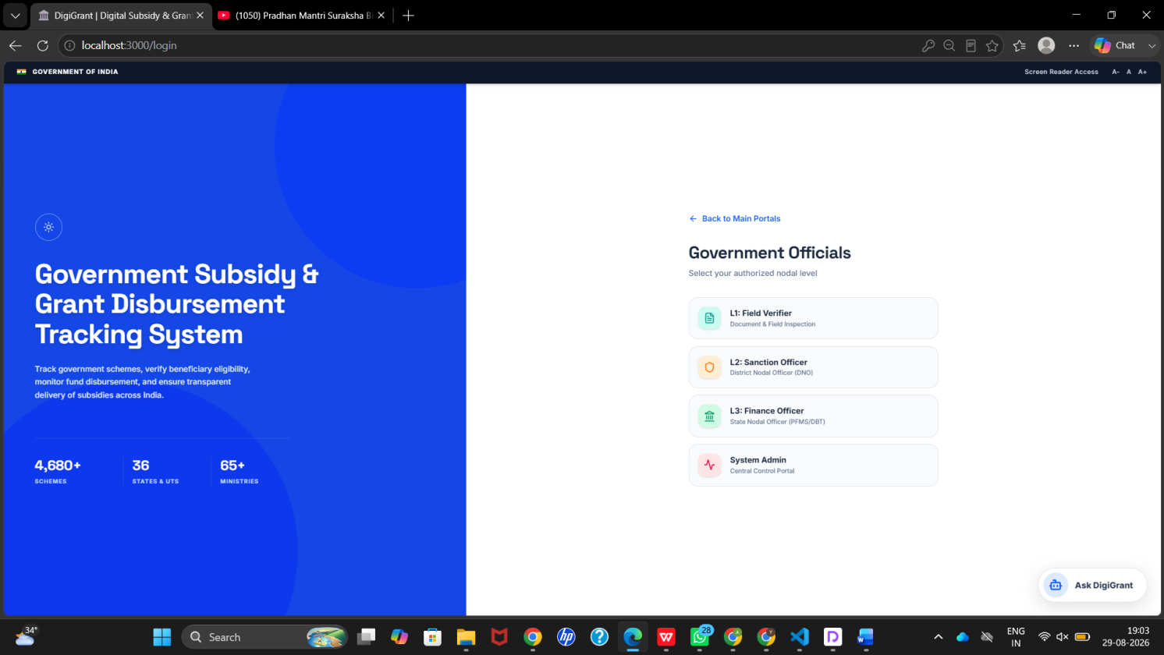
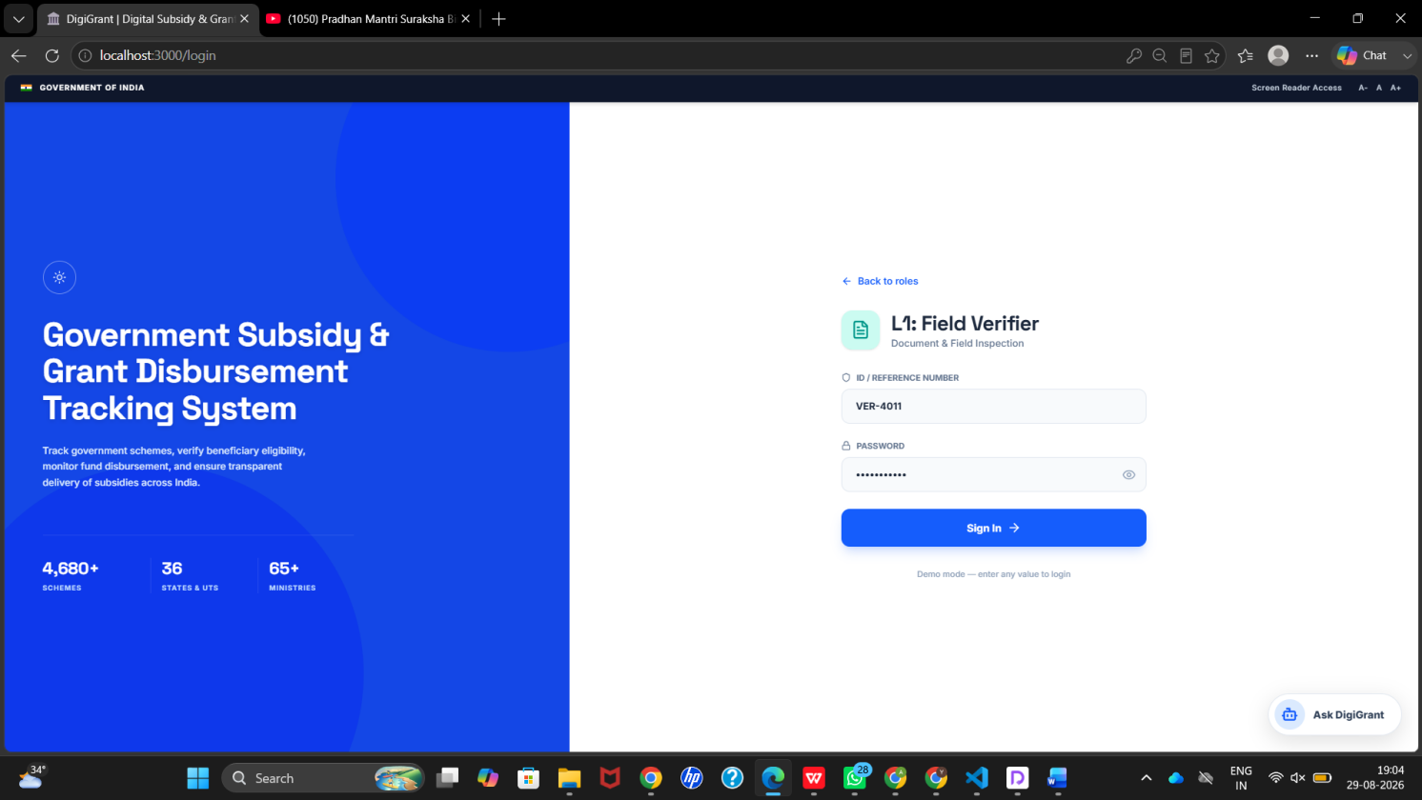
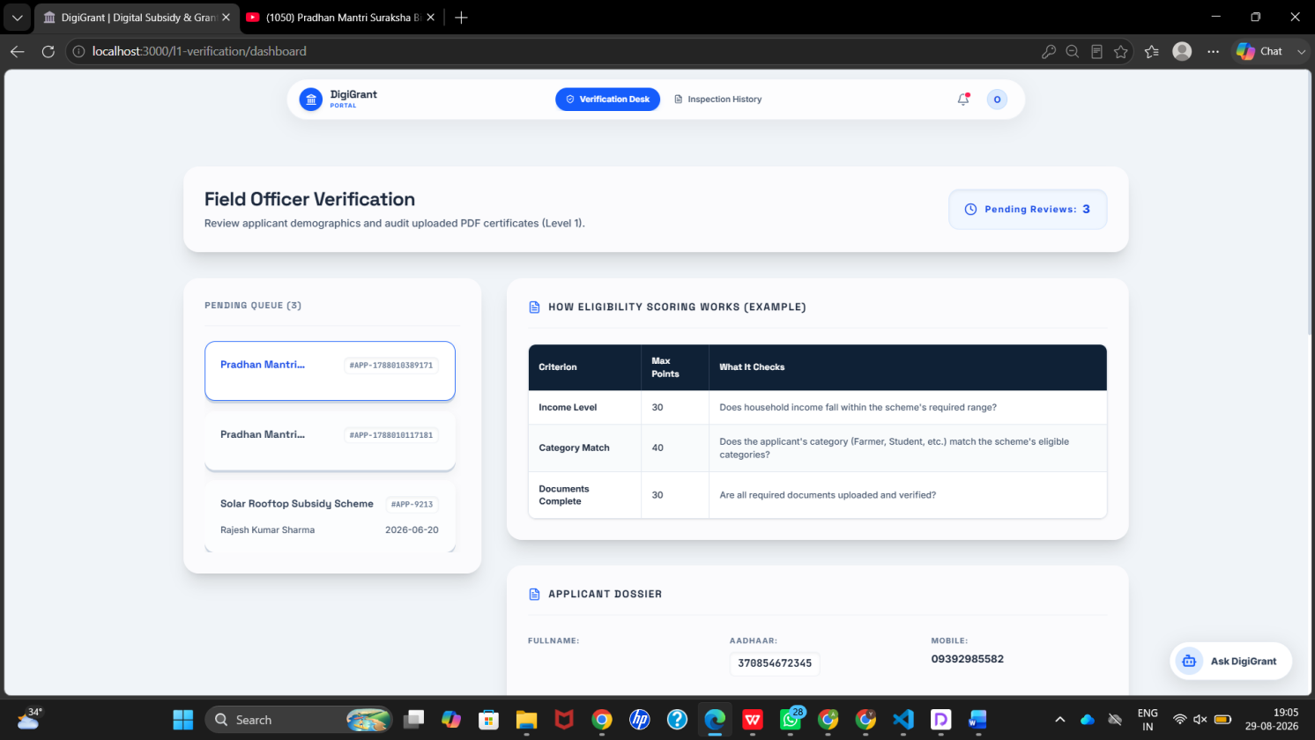

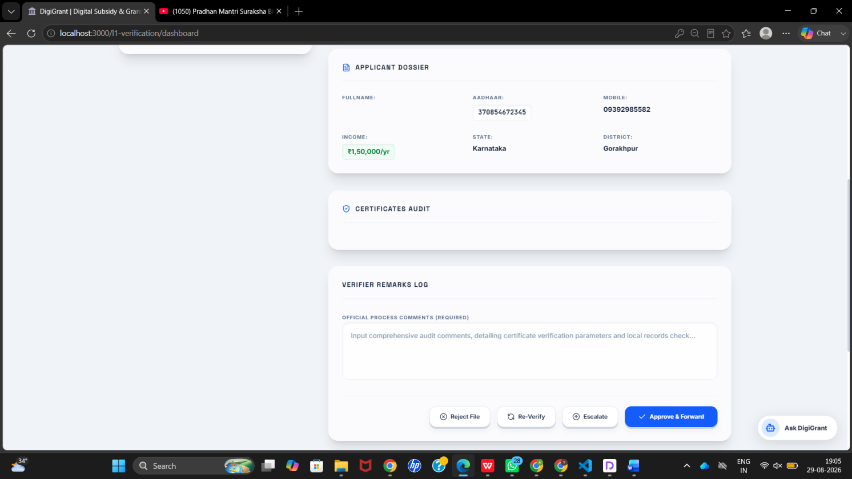

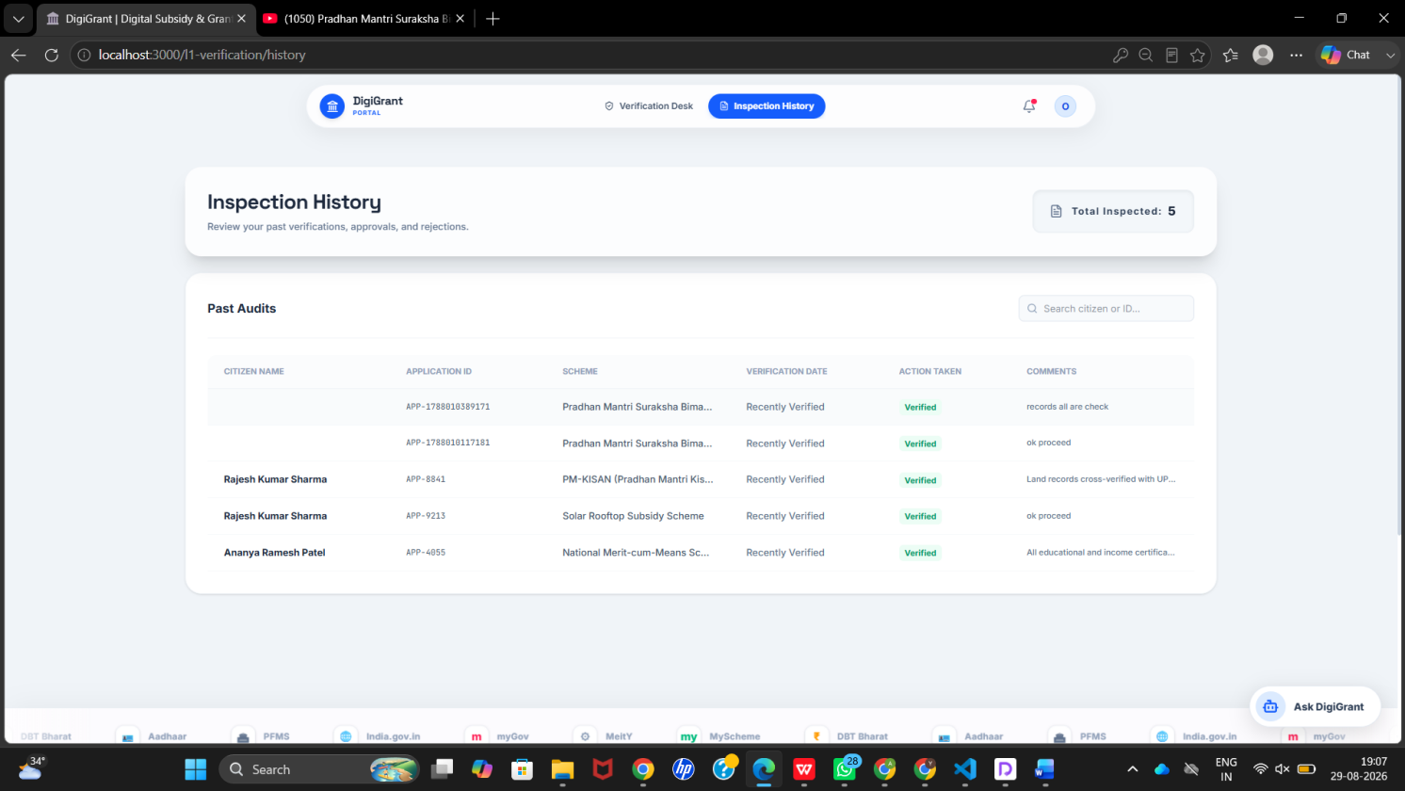

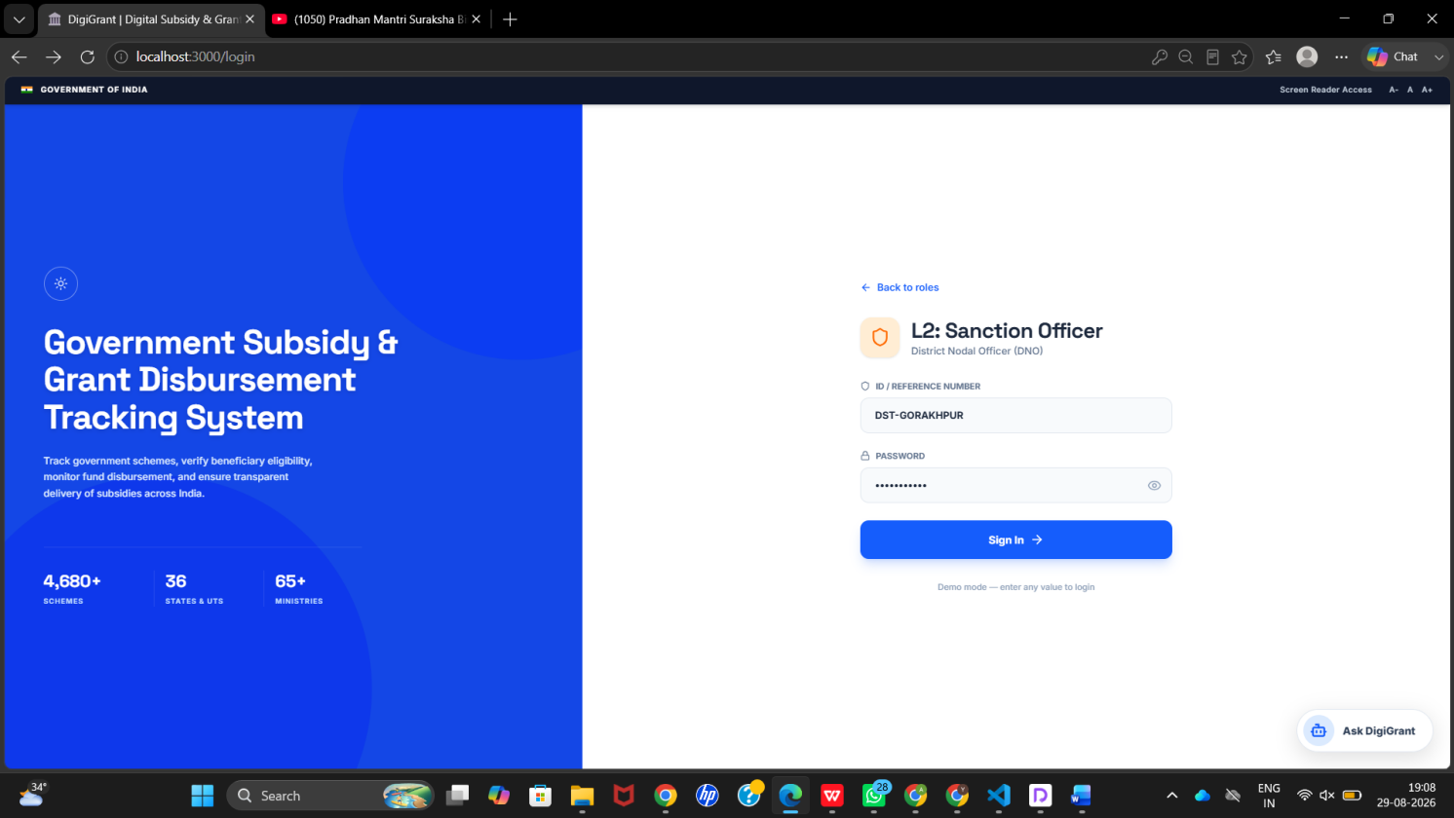

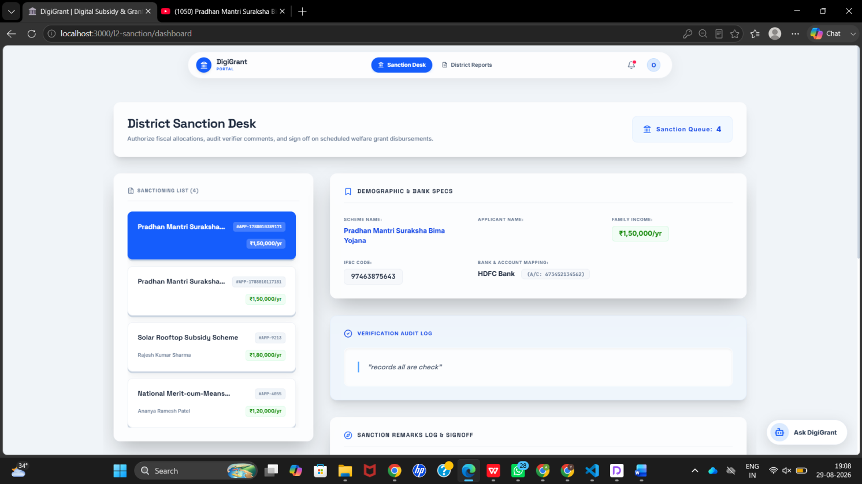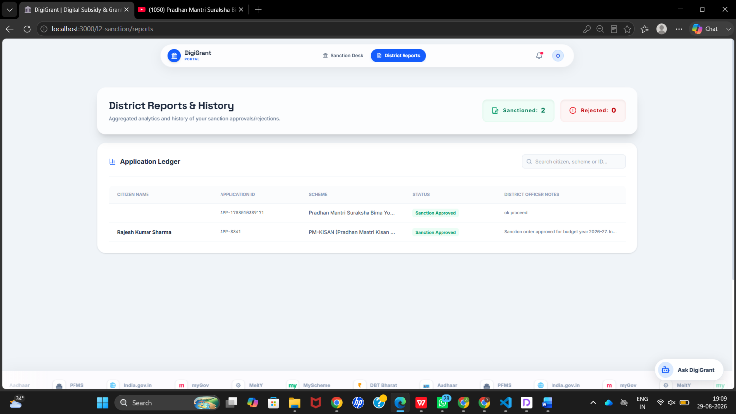
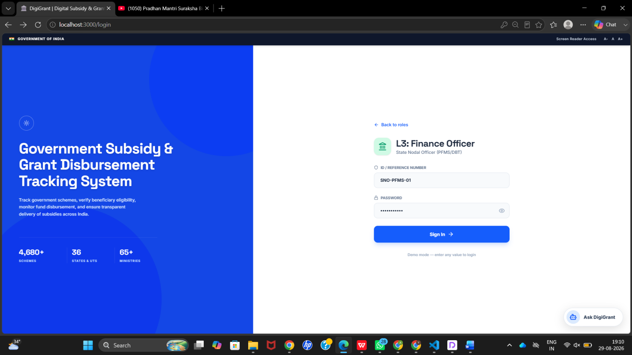

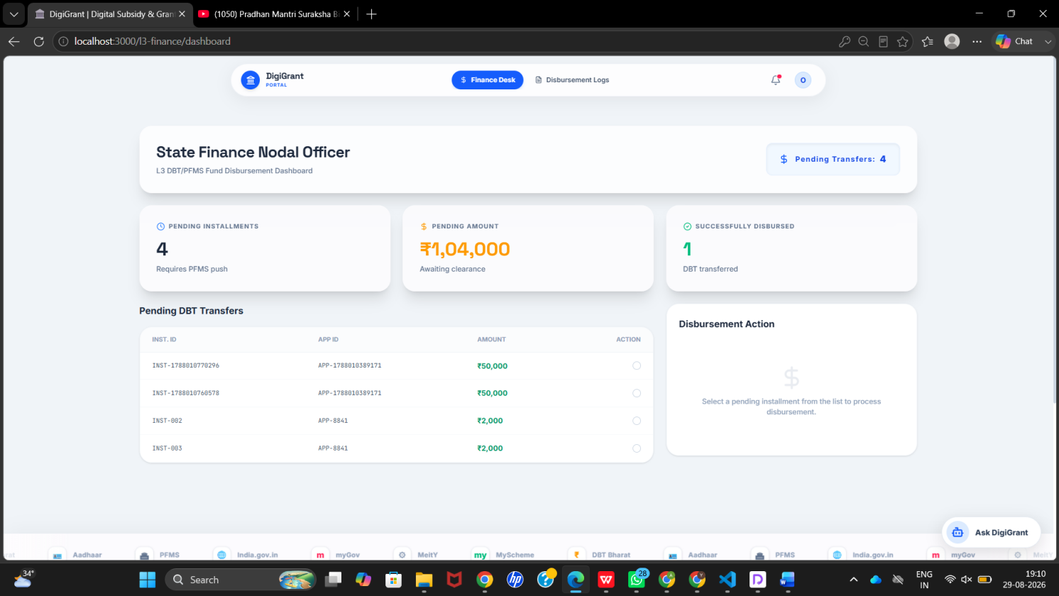

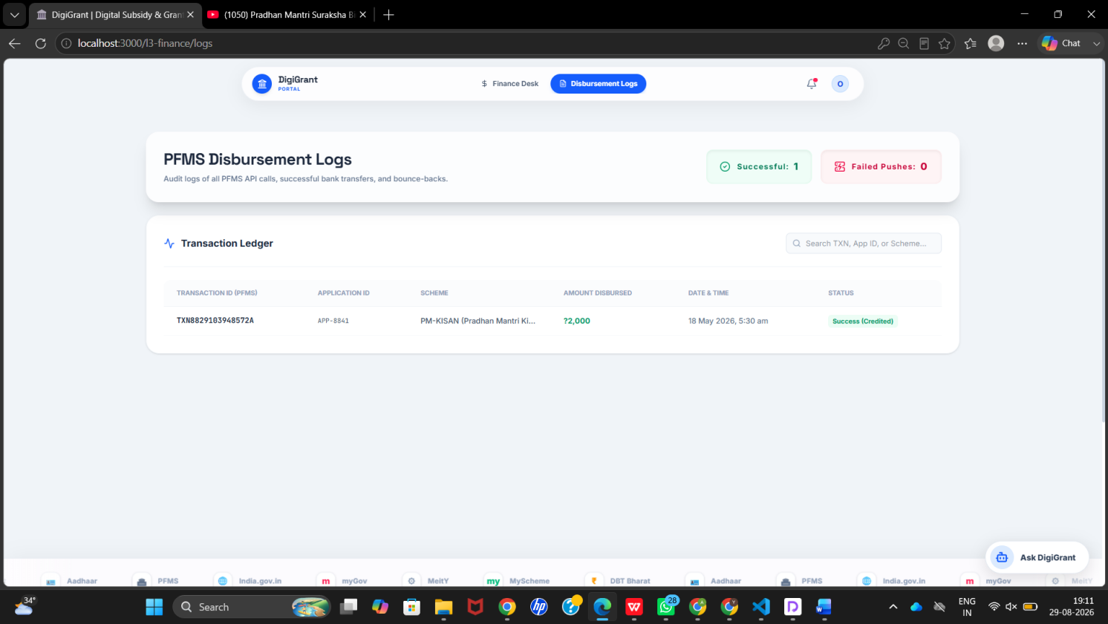

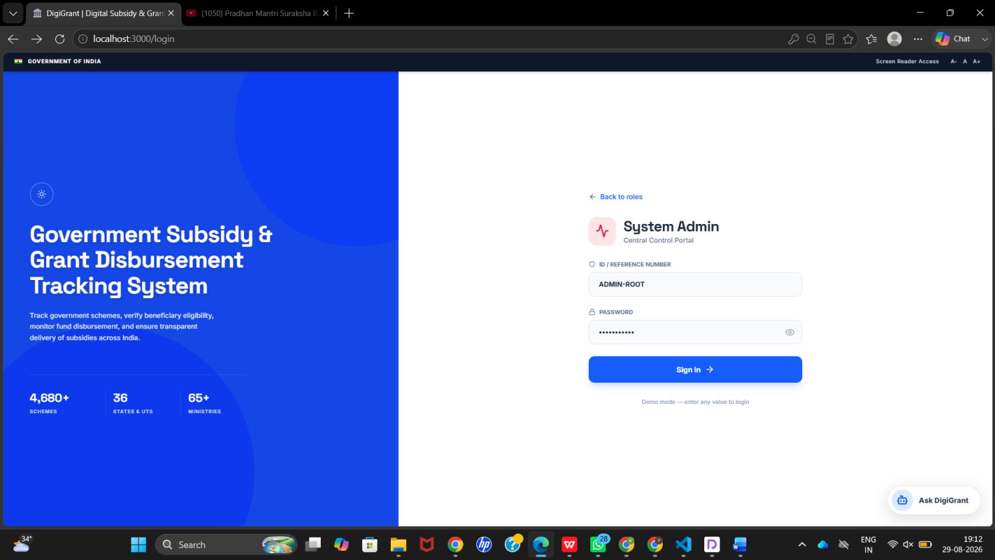

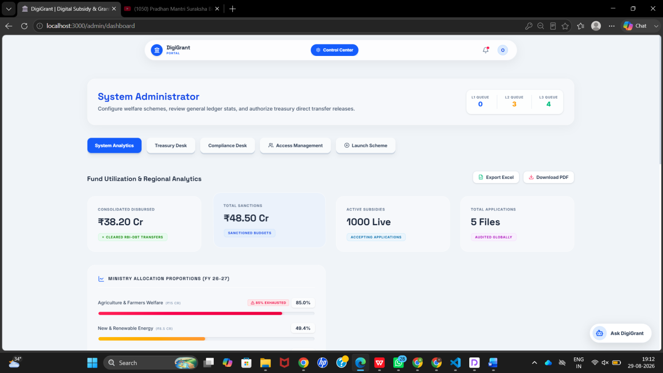

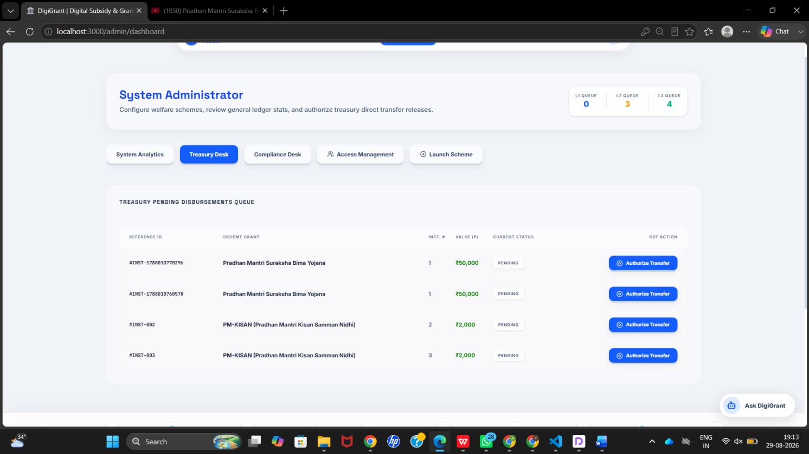

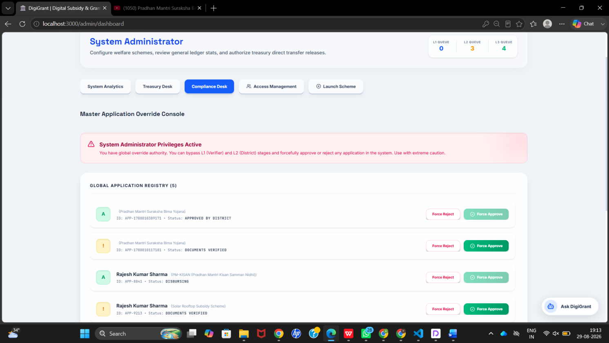

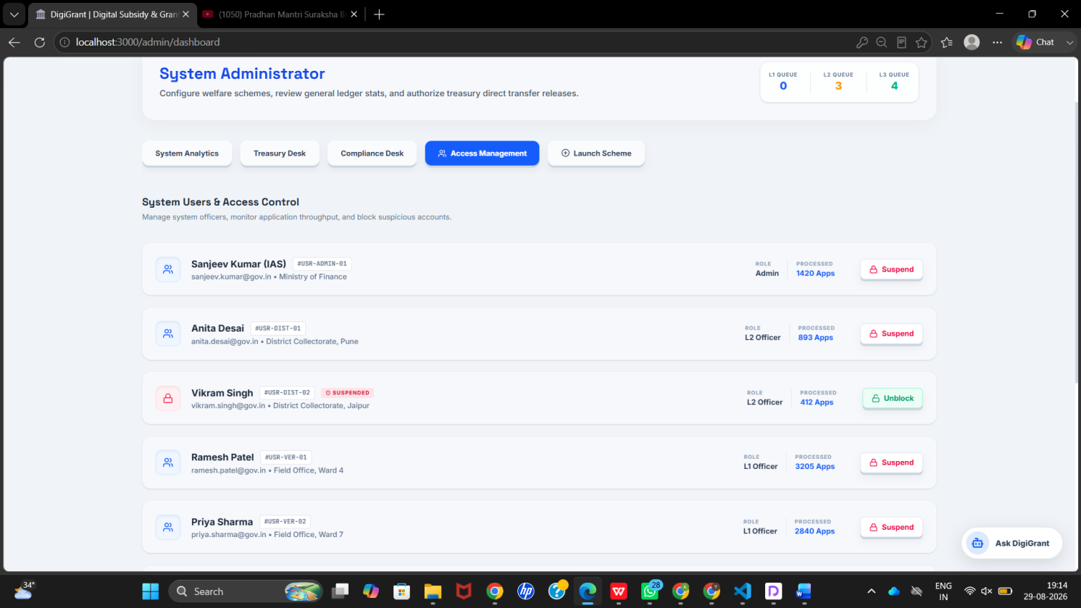

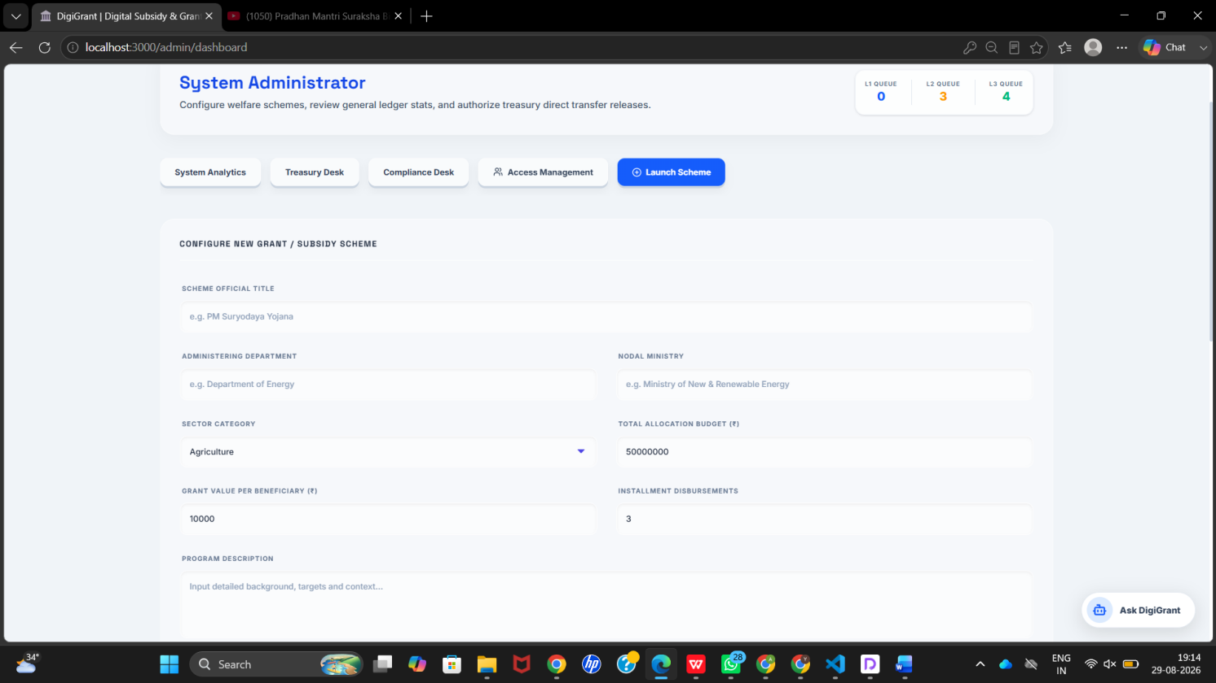

7. Challenges Faced

1. Implementing Role-Based Access Control
Challenge: The project involves multiple stakeholders such as Citizens, VLEs, L1 Verification Officers, L2 Sanction Officers, L3 Finance Officers, and Administrators. Each role requires different permissions and dashboards, making access management more complex.
Resolution: Implemented role-based authentication and authorization using Spring Security and JWT on the backend. Protected frontend routes using React Router and provided role-specific dashboards and functionality according to the authenticated user's role.

2. Managing the Multi-Level Application Workflow
Challenge: The subsidy and grant application process involves multiple stages such as application submission, document verification, sanction, and finance/disbursement. Maintaining the correct application status throughout these stages was challenging
Resolution: Designed the application workflow with clearly defined processing stages and role-specific operations. Each stage is handled by the appropriate user role, ensuring that applications progress systematically from submission through verification, sanction, and finance processing.

3. Frontend–Backend Integration
Challenge: Ensuring smooth communication between the React frontend and Spring Boot backend was challenging, particularly when integrating different modules and handling API responses, loading states, errors, and application data.
Resolution: Used Axios for REST API communication and TanStack React Query for managing asynchronous requests and server-side data. API service modules were separated from UI components to make integration and maintenance easier. API-related issues were identified and resolved during progressive integration.

4. Designing Role-Specific Dashboards
Challenge: Different stakeholders require different information and operations. Designing a common interface while providing separate functionality for Citizens, VLEs, verification officers, sanction officers, finance users, and administrators required careful planning.
Resolution: Implemented role-aware routing and dashboard structures. Reusable React components were used wherever possible, while individual dashboard features were developed according to the responsibilities of each user role.

5. File Upload Security
Challenge:Subsidy and grant applications require supporting documents, and handling these documents together with application information while maintaining a reliable workflow was challenging.
Resolution: Integrated document-upload functionality into the application workflow and provided access to submitted documents for authorized verification activities. Validation and controlled application processing were used to improve data reliability.

6. Database Design Complexity
Challenge: The system contains multiple related entities such as users, roles, government schemes, applications, verification information, sanction details, and finance-related information. Maintaining relationships between these entities while keeping the database consistent was challenging.
Resolution: Used PostgreSQL with Spring Data JPA/Hibernate to establish structured entity relationships and persistence. The database structure was planned according to the application workflow, and JPA repositories were used to manage database operations.

8. Learnings & Skills Acquired

Technical Skills
Full-Stack Development: Gained practical experience in developing a complete full-stack web application involving frontend development, backend APIs, database management, authentication, and frontend–backend integration.
• Backend Development: Gained hands-on experience with Java, Spring Boot, Spring Security, JWT authentication, RESTful APIs, Spring Data JPA/Hibernate, Maven, and modular backend architecture.
• Frontend Development: Developed practical knowledge of React, Vite, TypeScript, React Router, Axios, TanStack React Query, Tailwind CSS, reusable components, responsive design, and role-based interfaces.
• Database Management: Gained experience in PostgreSQL database design, entity relationships, JPA/Hibernate ORM, data persistence, and database migration concepts.
• Security: Learned practical implementation of JWT authentication, Role-Based Access Control (RBAC), protected routes, backend authorization, input validation, and controlled access to application information.
• API Integration: Learned how to design, consume, test, and integrate RESTful APIs between a React frontend and Spring Boot backend using JSON-based request and response formats.
• Version Control: Gained practical experience using Git and GitHub for source-code management, collaboration, tracking changes, and maintaining the project codebase.
• Build & Development Tools: Gained experience with Maven, Visual Studio Code/IntelliJ IDEA, GitHub, and API testing tools as part of the software development workflow.
Software Engineering Practices
• Agile Development: Learned how to organize project development into incremental activities and milestones while continuously reviewing and improving the product.
• Modular Development: Understood the importance of dividing a large application into independent functional modules to simplify development, testing, maintenance, and future enhancement.
• Separation of Concerns: Learned to separate frontend presentation logic, API communication, backend business logic, database operations, and security responsibilities.
• Continuous Integration: Gained experience integrating frontend and backend components progressively rather than waiting until the end of development.
• Debugging and Problem Solving: Improved the ability to identify technical issues, analyze their root causes, test possible solutions, and verify fixes systematically.
• Documentation: Learned the importance of documenting project architecture, implementation details, workflows, challenges, and development activities for future maintenance and evaluation.
Domain Knowledge
• Gained practical understanding of the government subsidy and grant application lifecycle.
• Learned how a digital system can support scheme discovery, application submission, document verification, sanction, finance processing, and application tracking.
• Understood the importance of transparency and accountability in government subsidy and grant disbursement workflows.
• Learned how different stakeholders such as Citizens, VLEs, Verification Officers, Sanction Officers, Finance Officers, and Administrators interact with a centralized application.
• Understood how role-based workflows can be used to implement separation of responsibilities within a real-world information system.
Soft Skills
• Team Collaboration: Worked collaboratively across frontend, backend, database, testing, and Agile responsibilities.
• Communication: Improved communication skills through discussions regarding requirements, implementation decisions, API integration, task progress, and project reviews.
• Time Management: Learned to organize development activities according to weekly milestones and project deadlines.
• Problem Solving: Developed the ability to analyze integration problems, implementation challenges, and workflow issues and work toward practical solutions.
• Adaptability: Gained the ability to learn and apply new frameworks, tools, libraries, and development practices during the internship.
• Presentation Skills: Improved the ability to explain technical implementation, project workflow, architecture, and project outcomes during reviews and demonstrations.

9. Testimonials from Team

Team 3—Akash keote,krishna shalwadi,goukulan,areeb,Hema nandini,shirsa roy
Working on the Government Subsidy & Grant Disbursement Tracking System through the Infosys Springboard Virtual Internship has been a valuable and enriching experience for our team. The internship provided us with an opportunity to work on a real-world problem and understand how different software development concepts are applied while building a complete web-based application.
From the initial requirement analysis and project planning to frontend development, backend development, database integration, testing, and documentation, we experienced different stages of the software development lifecycle. Working on a system involving government subsidies and grants helped us understand the importance of transparency, structured workflows, data management, and role-based access.
One of the major learning experiences was developing the application using modern full-stack technologies. The frontend team worked with React, Vite, TypeScript, React Router, Axios, and Tailwind CSS, while the backend team worked with Java, Spring Boot, Spring Security, JWT, JPA/Hibernate, and PostgreSQL. Connecting these components through RESTful APIs gave us practical experience in full-stack application development.
The project also helped us understand the importance of collaboration between different development roles. Frontend and backend components had to be developed and integrated progressively, which required regular communication, testing, debugging, and coordination. Using Git and GitHub helped us manage source-code changes and collaborate effectively as a team.
Another important achievement was implementing the multi-level application workflow involving Citizens, VLEs, L1 Verification Officers, L2 Sanction Officers, L3 Finance Officers, and Administrators. Seeing the different modules work together as a complete subsidy and grant processing system was a rewarding experience.
Beyond technical knowledge, the internship improved our communication, teamwork, time management, problem-solving, adaptability, and presentation skills. The challenges encountered during API integration, role-based access, database design, and workflow implementation provided valuable practical learning.
We are grateful to Infosys Springboard, our mentors, coordinators, fellow interns, and our institution for providing us with this opportunity. This project has given us meaningful exposure to industry-oriented software development and has strengthened our confidence in working on real-world full-stack applications.

10. Conclusion
The Government Subsidy & Grant Disbursement Tracking System developed during the Infosys Springboard internship has been a valuable and impactful learning experience for our team. Over the course of the project, we designed and developed a full-stack web application aimed at digitizing and streamlining the government subsidy and grant application and disbursement process.
The project successfully addressed the major objectives defined during the planning stage. The system provides a centralized platform for viewing government schemes, submitting subsidy and grant applications, uploading supporting documents, tracking application progress, performing verification, processing sanction activities, and managing finance and disbursement-related operations.
A major strength of the system is its role-based workflow. Different stakeholders, including Citizens, VLEs, L1 Verification Officers, L2 Sanction Officers, L3 Finance Officers, and Administrators, are provided with appropriate functionality according to their responsibilities. This structured approach improves separation of duties, transparency, and accountability throughout the application lifecycle.
From a technical perspective, the project provided practical experience in modern full-stack development. The frontend was developed using React, Vite, TypeScript, React Router, Axios, TanStack React Query, and Tailwind CSS, while the backend was implemented using Java, Spring Boot, Spring Security, JWT, Spring Data JPA/Hibernate, and PostgreSQL. RESTful APIs were used to establish communication between the frontend and backend.
The project also provided valuable exposure to Agile software development practices. The team worked through incremental milestones, divided responsibilities among different development areas, integrated modules progressively, tested the system continuously, and addressed issues through collaborative problem solving. Git and GitHub supported version control and team-based development.
Beyond the technical implementation, the internship helped us improve important professional skills such as teamwork, communication, time management, problem solving, adaptability, debugging, documentation, and presentation. Working on a real-world problem helped us understand the importance of planning, collaboration, security, maintainability, and continuous testing in software development.
Overall, the Government Subsidy & Grant Disbursement Tracking System represents a meaningful application of software engineering concepts to a real-world administrative problem. The experience gained through this project has strengthened our technical foundation and provided practical knowledge that will be valuable for our future academic projects and professional careers.

11. Acknowledgements
We would like to express our sincere gratitude to Infosys Springboard for providing us with the opportunity to participate in the Virtual Internship and work on the Government Subsidy & Grant Disbursement Tracking System. This internship provided us with valuable exposure to real-world software development and enabled us to apply our academic knowledge in a practical project environment.
We extend our heartfelt thanks to our mentors and internship coordinators for their guidance, valuable feedback, continuous encouragement, and support throughout the project. Their suggestions helped us understand software development practices and improve the quality of our implementation.
We are also grateful to the Infosys Springboard team and fellow interns for creating a collaborative learning environment. The discussions, interactions, and experiences shared during the internship contributed significantly to our technical and professional growth.
We would like to thank all our team members for their cooperation, dedication, communication, and support throughout the development process. The successful completion of the project was made possible through our collective efforts across frontend development, backend development, database management, API integration, testing, Agile coordination, and documentation.
Finally, we are thankful to everyone who directly or indirectly contributed to the successful completion of this project. The knowledge and experience gained through this internship will remain an important part of our academic and professional journey.

